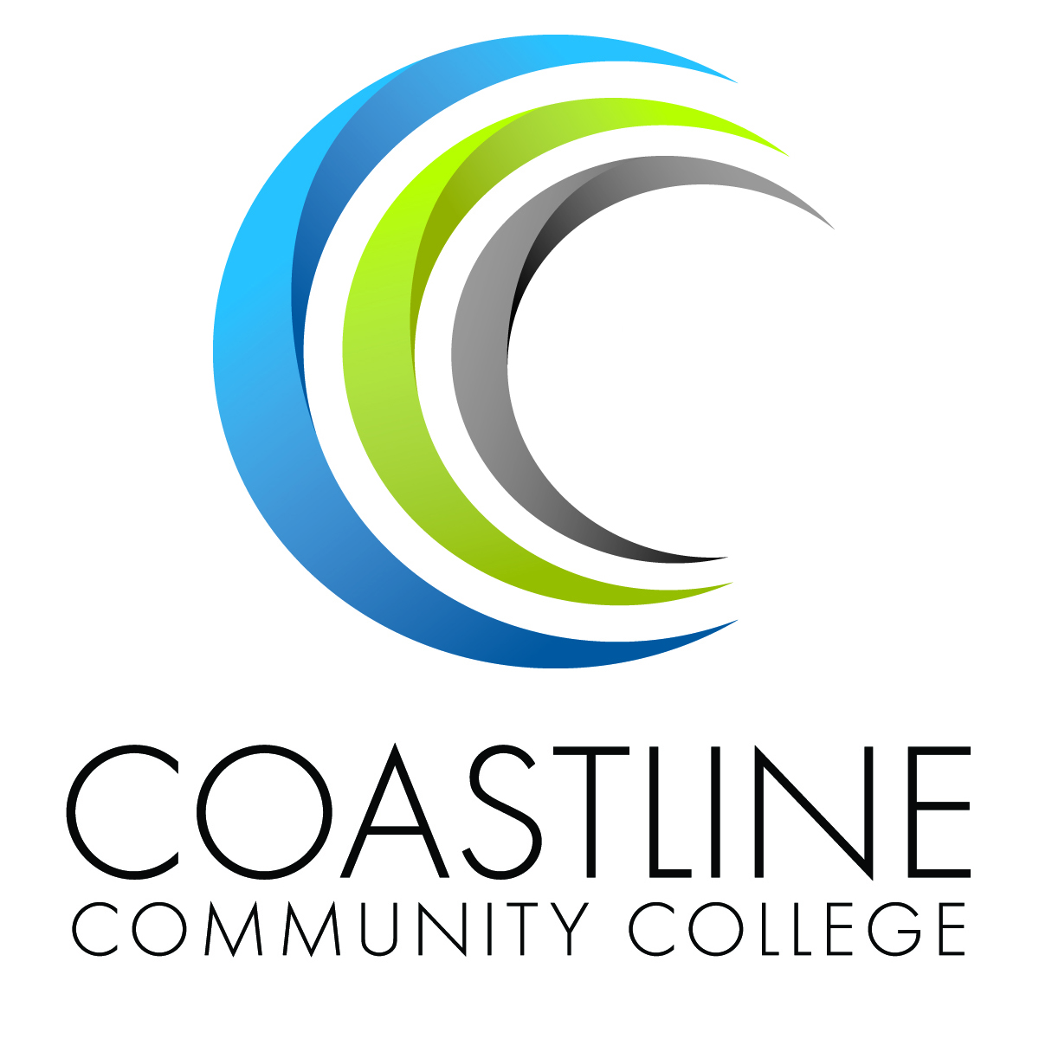 | COASTLINE COMMUNITY COLLEGE  BUDGET DEVELOPMENT – FY 2014/2015  Resource Allocation Proposal
 |  | Administrator Use:

Originator:
Program or Department Name:
Area Dean:
Area Vice President:
Account Code:
Total Amount Requested:
One-Time Funding:
On-Going Funding:
Department Priority Ranking: |  | of

- What are you requesting? Why is the request being made? Where was the need identified? Describe your goal(s) for this proposal? How will this impact students or institutional services?

- List areas of compelling evidence that would support your proposal (if applicable).
- Compliance

- Health & Safety

- Other

- Demonstrate how your request is supported by at least one of the following: a) Program Review/Annual Institutional Plan Report b) Student Learning Outcomes, Program Learning Outcome, Institutional Learning Outcome, Service Area Outcome c) other planning documents.
a)

b)

c)

- Describe how your request supports at least one or more of the following Institutional Plans:
- Education:

- Technology:

- Staffing:

- Facility:

- Describe your Implementation Plan:

- Identify measureable outcomes for this activity or request (include connections to SLOs):

